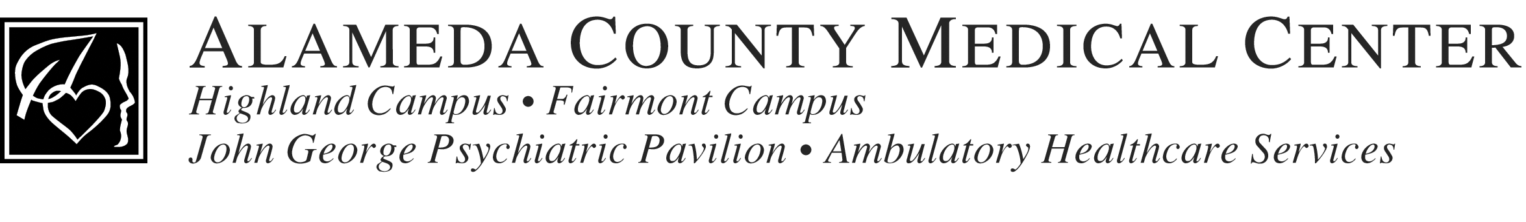

BOARD OF TRUSTEES RETREAT
SATURDAY, SEPTEMBER 30, 2006
1:00 – 4:00 P.M.
Classroom A, Highland Campus

Central Administration Offices Located at Highland Hospital
1411 East 31st Street Oakland, CA. 94602
Barbara Miller – Elegbede, Clerk of the Board 510-437-8468

Board Members:
J. Bennett Tate, President Stan Schiffman, Vice President
Daniel Boggan, Jr. Dr. Floyd Huen
Ron Nelson Joe Phan
Barbara Price Dr. Theodore Rose
Anthony Slimick Ilene Weinreb

NOTICE

SPECIAL BOARD RETREAT OF THE BOARD OF TRUSTEES

1:00 TO 4:00 P.M.

DISCUSSION OF STRATEGIC PLANNING INCLUDING FACILITY PROGRAMS, AND SERVICE PLANNING

