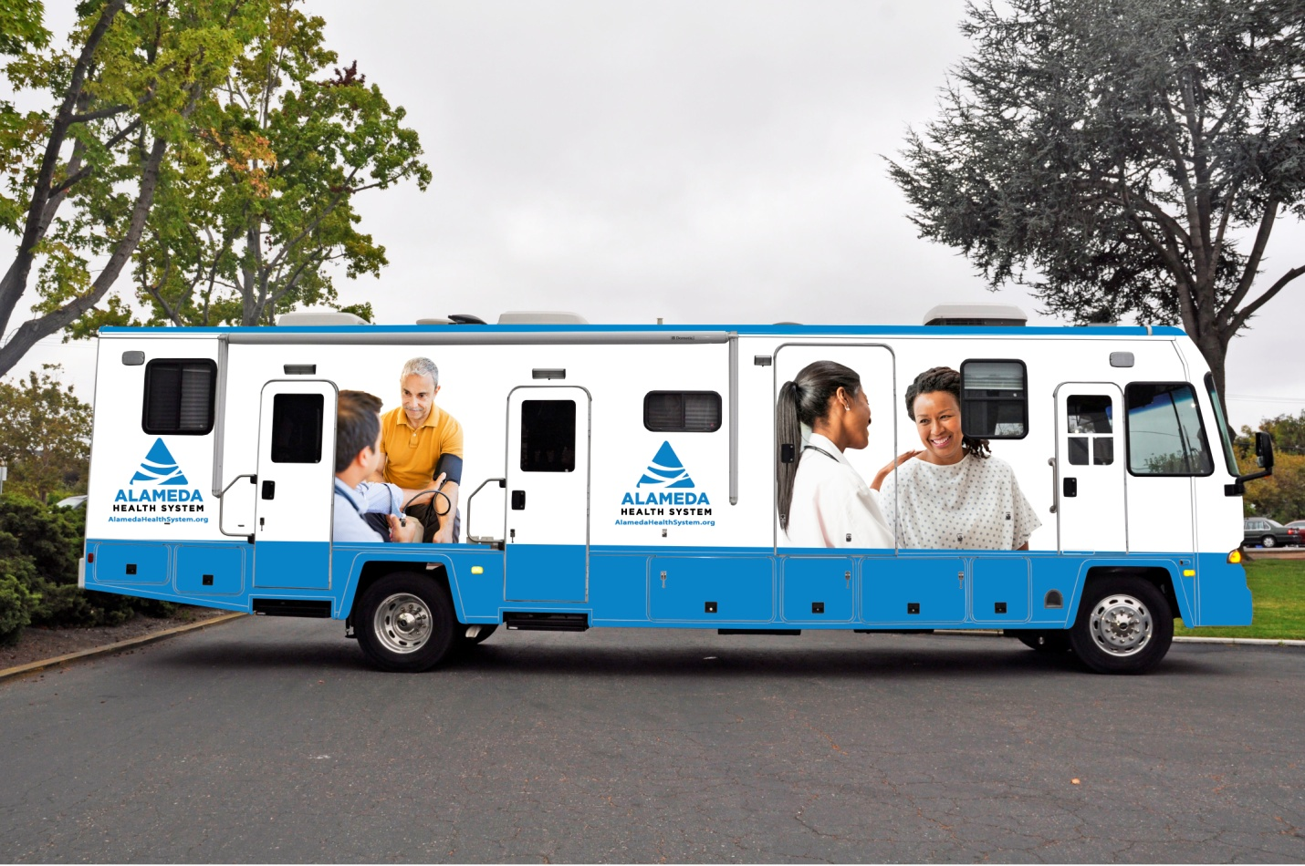

Please contact Brenda Chu Chan 510-535-7645 for today’s service locations and hours

**Mobile Health provides an easy way to get care today, link to primary care for the future, and learn about other organizations in your community that can help you.**

***Mobile Health Clinic has a dynamic schedule through out Alameda County. Locations include monthly stops at the following locations:***

**El Shaddai MIsinistries,** 565 E. Lewelling Ave, San Lorenzo, CA 94580

**EOCP Crossroads**, 7515 International Blvd, Oakland , CA 94621

**Home Depot,** at High Street Oakland

**Cronin House**, 2595 Depot Road,

Hayward, CA 94545 (not open to public)

**Fairmont Hospital,** 15400 Foothill Blvd,

San Leandro, CA 94578

**Multi Cultural Institute**, Berkeley (Mobile parks at 4th Street near RR tracks) or Multi-Agency Service Center (MASC) Berkeley

**New Hope,** 22110 Montgomery Street, Hayward, CA 94541

**Home Depot,** 30055 Industrial Pkwy SW, Union City, CA 94587

**Henry Robinson,** 559 16th Street, Oakland, CA 94612

**South County Wellness Center,** 40963 Gimmer Blvd, Fremont, CA 94538

**South Hayward Parish,** **27287 Patrick Ave, Hayward, CA 94544**

**STAIR Center,** Second St, between Cedar and Virginia, Berkeley

**Towne House,** 629 Oakland Ave, Oakland CA 94611

**We diagnose, treat, educate, and make medical referrals for:**

* Hypertension
* Diabetes
* Depression
* Back Pain
* Headaches
* Abdominal pain
* Muscular/skeletal pain
* Asthma
* Arthritis
* Ulcer disease
* Seasonal Vaccinations
* Substance Abuse
* Other common medical issues

**We provide:**

* Over-the-counter medication
* Medical advice and referrals
* Mental Health advocacy and referrals
* Case management and benefits assistance

### 

**Mobile Health**

**We DO NOT (referrals made if needed):**

* Diagnose or treat HIV, AIDS, or active TB. Cases will be referred for appropriate follow-up care
* Treat chronic pain syndromes
* Treat medical emergencies that cannot be handled on the van
* Offer pediatric follow-up or well-baby checks
* Provide specialized care for pregnant women
* Provide optometry and ophthalmology services
* Offer specialist care in dermatology, podiatry, orthopedics, mental health or others
* Provide full physical examinations
* Provide AC Transit or other disability forms



**AlamedaHealthSystem.org**